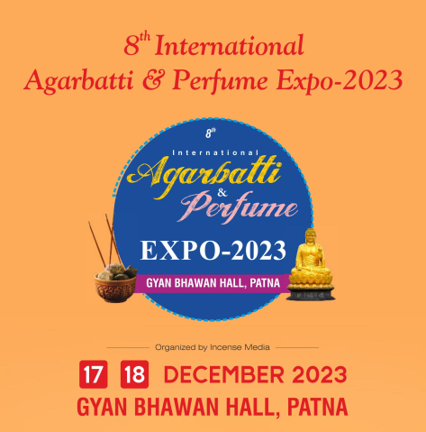
8th International Agarbatti & Perfume Expo-2023
Incense | Fragrance | Spirituals | Pooja Products | Allied Industries

17 & 18 DECEMBER 2023 (10 AM to 6 PM)
Multipurpose Hall, Gyan Bhawan, Patna

Sponsorship Opportunities

Main Sponsor (1 No.) – Rs. 10 Lakh + GST

Benefits :-
1. 36 meters stall in exhibition area
2. 12x8 feet hoarding in exhibition area (2 Nos.)
3. Logo on invitation cards
4. Media coverage at local/national level
5. Promotion of the event by 2 of our International Trade Magazine (with your Logo)
6. Announcement of you brand name during whole event, on frequent basis
7. 10 people lunch for 2 days
8. Social media promotion through facebook. More than 100,000 people connected to us
9. Logo on entry badge
10. Lamp lightening opportunity

Co-Sponsors (7 Nos.) – Rs. 7 Lakh + GST

Benefits :-
1. 24 meters stall in exhibition area
2. 12x8 feet hoarding in exhibition area
3. Logo on invitation cards
4. Media coverage at local/national level
5. Promotion of the event by 2 of our International Trade Magazine (with your Logo)
6. Announcement of you brand name during whole event, on frequent basis
7. 6 people lunch for 2 days
8. Social media promotion through facebook. More than 100,000 people connected to us
9. Small Logo on entry badge
10. Lamp lightening opportunity

Other Sponsorship / Branding Categories:-

Registration Bag Sponsor : 2 Lakh + taxes

Visitor / Exhibitor Entry Badge & Lanyards Sponsor : 2 Lakh Rs. Each + taxes

Food Sponsor (Lunch for a day) : 3 Lakh + taxes

Water Bottle Sponsor : 1.5 Lakh + taxes

Tea / Coffee Sponsor : 1.5 Lakh + taxes

Gift Sponsor (To be distributed with Registration Kit) : 50,000 + taxes
(Gifts to be provided by Sponsor)

Branding at Exhibition Venue (Flex Board 12x8 Feet) : 40,000 + taxes

Event Organized By

